https://shorturl.at/G2IAP 29 Jan 2025

G17 BEE
- Middlewares (Deep Dive)

=================================================
Middleware Deep Dive (For Practice, Applications out of scope currently)
=================================================

- Application-level Middleware

//initialyse project
//>npm init -y
//download express module
//>yarn add express --save
// Define port
const port = 8080
// Import the express module
const express = require('express') // Express library for creating the server
//Create rest object
const app = express()

app.listen(port, () => {
console.log(`Server is running on port ${port}`)
})

Eg 1 Logging Incoming Requests
Problem Definition: Demonstrate to log HTTP method and URL for each incoming request using application-level middleware.

// Application-level middleware to log the HTTP method and URL of each incoming request
app.use((req, res, next) => {
console.log(`${req.method} ${req.url}`) // Log the request method and URL
next() // Pass control to the next middleware or route handler
})

app.get('/', (req, res) => {
res.send('Hello, World!') // Respond with 'Hello, World!' when the root URL is accessed
})

/*
Steps to Execute:
>node server
Open a browser or Postman and navigate to `http://localhost:8080/`.
Check your terminal to see the HTTP method and URL being logged for the request.
*/

Eg 2 Setting a Custom Header for All Responses
Problem Definition: To set a custom header (X-Powered-By) for every HTTP response using application-level middleware.

// Application-level middleware to set a custom header for all responses
app.use((req, res, next) => {
res.setHeader('X-Powered-By', 'Express') // Set custom header 'X-Powered-By'
next() // Pass control to the next middleware or route handler
})

app.get('/', (req, res) => {
res.send('Hello, World!') // Respond with 'Hello, World!'
})

/*
Steps to Execute:
>node server
Open a browser or Postman and navigate to `http://localhost:8080/`.
Inspect the response headers in the browser's developer tools or in Postman to see the `X-Powered-By: Express` header.
*/

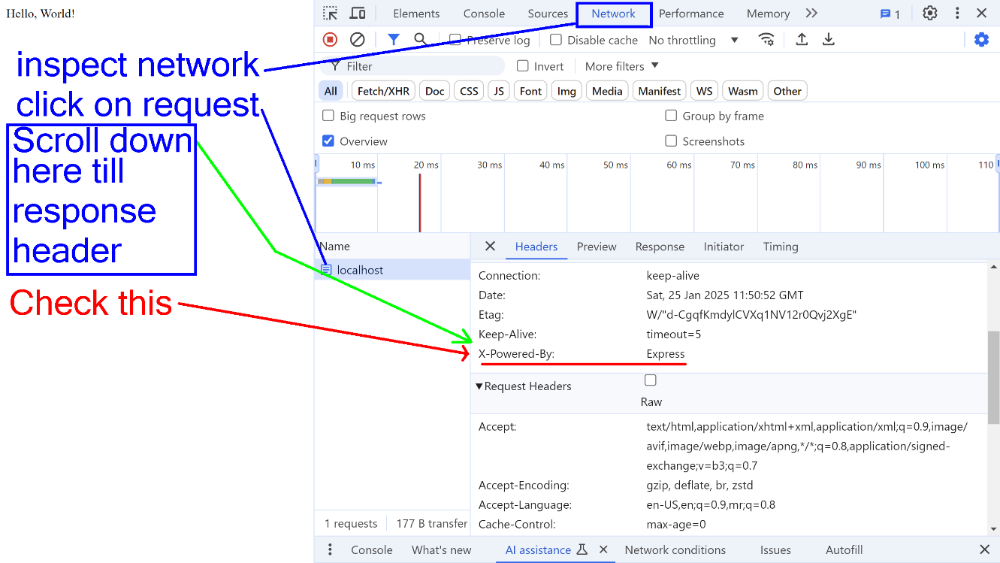

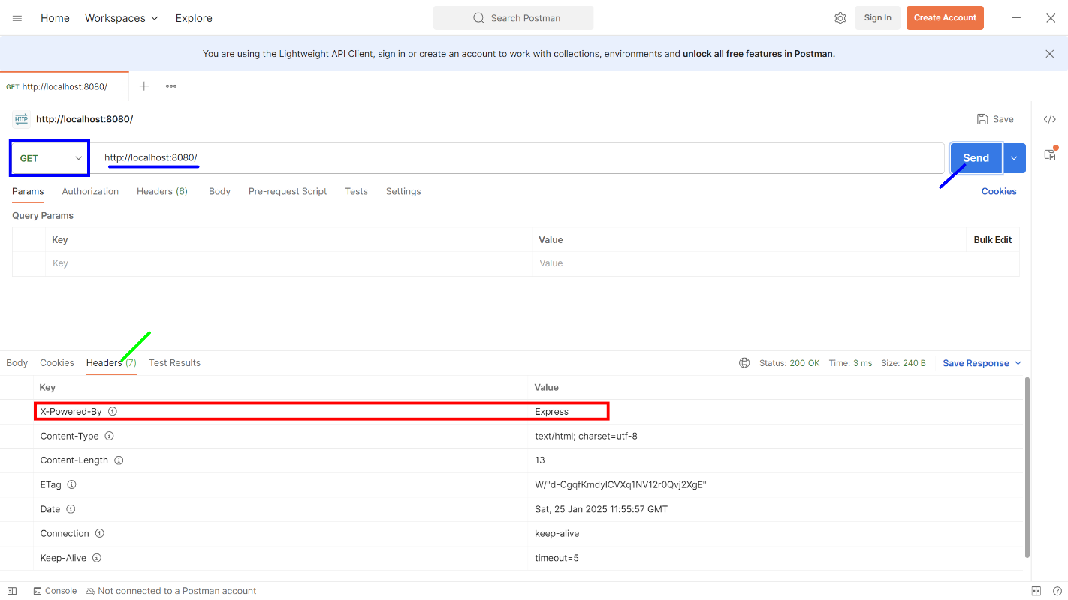

Eg 3 Authentication for All Routes
Problem Definition: Add a basic authentication middleware for all routes, blocking access if no Authorization header is provided.

// Application-level middleware to require authentication for all routes
app.use((req, res, next) => {
if (!req.headers.authorization) { // Check if authorization header exists
return res.status(403).send('Forbidden') // Respond with Forbidden if no authorization
}
next() // Pass control to the next middleware or route handler
})

app.get('/', (req, res) => {
res.send('Hello, World!')
})

/*
Steps to Execute:
>node server
Open Postman and make a GET request to `http://localhost:8080/`.
- Without any `Authorization` header, the response should be `403 Forbidden`.
- Add an `Authorization` header with any value to see the successful response.
*/
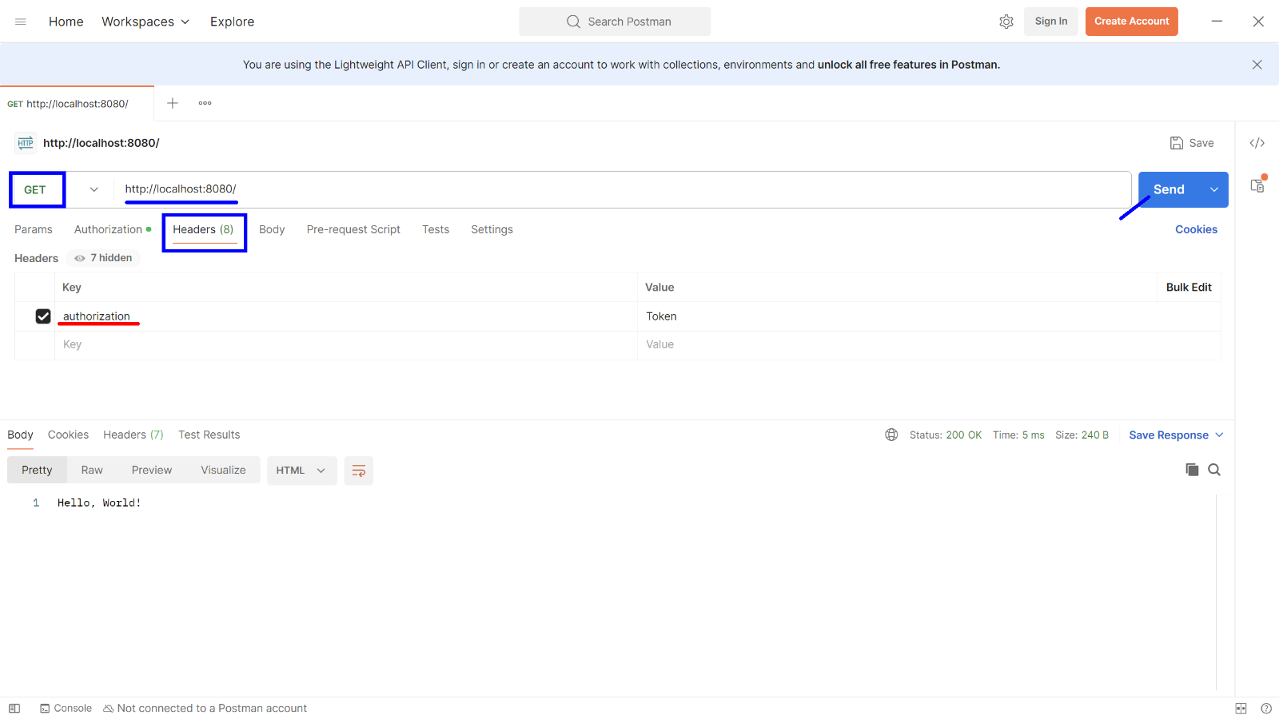

Eg 4 Request Body Parsing
Problem Definition: To use application-level middleware to parse incoming JSON request bodies.

// Application-level middleware to parse incoming JSON request bodies
app.use(express.json()) // Parse JSON body

app.post('/', (req, res) => {
res.send(`Received data: ${JSON.stringify(req.body)}`) // Respond with received data
})

/*
Steps to Execute:
>node server
Open Postman, set the request method to `POST`, and use the URL `http://localhost:8080/`.
In the "Body" section, select `raw`, choose `JSON`, and add data like:
{
"name": "Chitkara University",
"department": "CSE"
}
*/

